

GROUP ASSIGNMENT (5%)

Subject | : | Human-Computer Interaction (SECV2113)
Session | : | 2025/2026 Semester 1
Task | : | Heuristic Evaluation and User Journey Map
Title | : | Evaluation Report and Journey Map Suggestion
Duration | : | 1 Week (3 JANUARY 2026 until 9 JANUARY 2026 before 12.00 pm)
Submission | : | This is a GROUP ASSIGNMENT and must be submitted  INDIVIDUALLY
- To the TEAM that has been assigned for evaluation
- Upload the report in .PDF format via UTM E-learning

Instruction (Part 1):
To experience how inspection is conducted, in this assignment your team will take up the role of usability expert to inspect using Heuristic Evaluation (HE) onto another team’s prototype*, as assigned by your lecturer. Refer to these paired groups: Group 1: Group 2, Group 3: Group 4, Group 5: Group 1.

*Each group is to provide their prototype link, persona + scenario (of one type of target user only) and user tasks to the evaluators

Based on Table 1, your team will apply Nielsen's heuristics to evaluate the designed user interfaces and rate the severity of each issue found.

Table 1: The 10 Heuristics and the Severity Rating
Heuristics | Severity Rating (1-low, 4-high)
- Visibility of system status.  - Match between system and real world.  - User control and freedom.  - Consistency and standards.  - Error prevention.  - Recognition rather than recall.  - Flexibility and efficiency of use.  - Aesthetic and minimalist design.  - Help users recognize, diagnose, recover from errors.  - Help and documentation. | - Cosmetic issue – affects the appearance and should be fixed only if time permits  - Minor issue – hinders the user’s ability to navigate and should be fixed when possible  - Major issue – Frustrates or confuses users and requires repair as soon as possible  - Catastrophic issue – prohibits users from performing their given task and requires an immediate modification

Evaluate the prototype based on the given persona, scenario and user tasks. Take note of where an issue was found, label the heuristic that it has violated and its severity rating, and take a screenshot of the issue.

For each heuristic, you would probably find more than 1 instance of violation (on different pages/screens/interface/etc.), or none at all. List all you can find in a Heuristic Evaluation (HE)

Table (refer to Table 2). Please ensure that your HE table consists of at least 8 of these instances.

Table 2: Example of HE Table
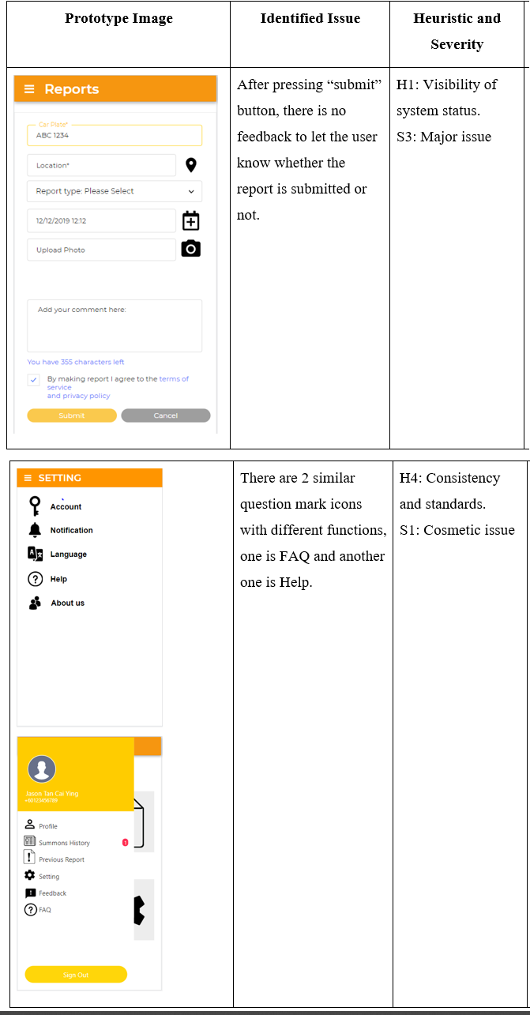

Add at least another 6 more violations...

Instruction (Part 2):
Your team will now change hats from being usability experts to designer team. You will incorporate the heuristic findings into a user journey map.

Recreate the template shown in Figure 1. Complete each section of the map:
- Section A – The provided persona + scenario

- Section B – Journey phases based on the user tasks
- Section C – List the actions taken by the user in each phase
- Section D – Emotion plots and quotes on the user’s thoughts and feelings in each phase.
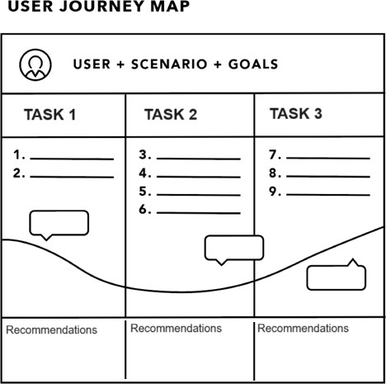
- Section E – Highlight the issues found during heuristic evaluation as pain points. Identify the opportunities (provide recommendations for improvements).
A
B
C

Figure 1: Example of a User Journey Map
D
E

Write an introduction of your evaluation report and place the HE Table and User Journey Map together in the report (refer to the scoring rubric on what needs to be included). Submit through e-learning.

References:
- TOPIC 07b – User Journey Map
- TOPIC 08 – Evaluation
- How to run a heuristic evaluation
- Nielsen’s 10 heuristics

Scoring rubric:

Item no. / CLO  / Taxonomy | Absent (0) | Minimal (1) | Standard (2) | Good (3) | Excellent (4) | Weight | Score
Introduction | Not provided | Explain the evaluation process | Explain the evaluation process  and  the prototype | - | Explain the evaluation process  and  the prototype and  the description of persona, scenario and the three user tasks that was used | 1 | /4
HE results | Not provided | Violations are too little (2 or less) | Violations are not enough (3~5)  and  not all are correctly categorized  and/or  some ratings are not logical | At least 6~8 violations were found with images  but  not all are correctly categorized  and/or  some ratings are not logical | At least 8 violations (or more) found with images  and  all are correctly categorized  and  No inaccuracies and clear, logical rating | 3 | /12
User journey map | Not provided | - | Incomplete sections | All sections were filled in but not all followed the criteria of user journey mapping | All sections are filled in by following the criteria of user journey mapping | 1 | /4
Recommendati on (in the user journey map) | Not provided | Recommend potential solutions to some problems only | - | Recommend potential solutions to all problems but only some are based on principles and guidelines | Recommend potential solutions to all problems and all are correctly based on principles and guidelines | 2 | /8

28/28 = 5%

